Your TRICARE® Pharmacy Benefit

Express Scripts, Inc. is the pharmacy contractor for the TRICARE Pharmacy Program. TRICARE’s pharmacy benefit is available to active duty service members, National Guard and Reserve members, retirees, their families, survivors, and others registered in the Defense Enrollment Eligibility Reporting System (DEERS). The program provides outpatient prescription drugs to 9.5 million beneficiaries and is designed to give you the drugs you need, when you need them, in a safe, easy, and cost-effective manner.

The TRICARE Pharmacy Program offers several ways for you to fill your prescriptions. Depending on your prescription drug(s), options include TRICARE Pharmacy Home Delivery; military pharmacies; and a large network of retail pharmacies.

TRICARE Pharmacy Home Delivery is recommended for prescriptions you take on a regular basis and is your least expensive option when not using a military pharmacy. If your prescription drug is available, you can get up to a 90-day supply for most drugs. It’s easy to get started:

Online: Create your online account (Express-Scripts.com/TRICARE) to order refills quickly and easily. You can pay by check or credit card.
Mail: Print, fill out and mail the Mail Order Registration Form (Express-Scripts.com/TRICARE/benefits/dodMailOrderForm.pdf) along with your 90-day prescription to the address listed on the form.
Phone: Call 877.363.1296 and a patient care advocate will work with your doctor to transfer your maintenance medications to TRICARE Pharmacy Home Delivery. Be sure to have your prescription bottle handy.
MTF: Ask your pharmacist if your prescriptions can be automatically transferred to Home Delivery.

Available benefits when you fill maintenance medications in TRICARE Pharmacy Home Delivery
- 24/7 access to pharmacists and nurses who can answer questions about your medication
- Multiple checkpoints that enhance safety and accuracy
- Formulary generics are FREE
- Standard shipping is FREE
- Picking up your prescriptions is as easy as picking up your mail

Your Home Delivery Copayments
Save with a 90-day supply of your medication from TRICARE Pharmacy Home Delivery.
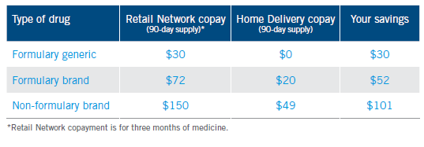
Learn more by visiting Express-Scripts.com/TRICARE

